#### https://tds-images.thedailystar.net/sites/default/files/styles/very_big_1/public/images/2024/09/25/jammu_kashmir_election_0.jpg

[**Voting for 2nd phase of assembly elections in Jammu and Kashmir begins**](https://www.thedailystar.net/news/asia/india/news/voting-2nd-phase-assembly-elections-jammu-and-kashmir-begins-3711711)

Polling in the second phase of the assembly elections in Jammu and Kashmir, India’s only Muslim-majority

#### [**Geopolitical Insights / India, US both need a stable Bangladesh**](https://www.thedailystar.net/opinion/geopolitical-insights/news/india-us-both-need-stable-bangladesh-3711156)

However, regardless of the nature of international involvement, the ultimate responsibility for a stablsidelines of UN General Assembly

"We must pay attention," Yunus said at a high-level discussion on the Rohingya crisis h d on …….

[**Hezbollah fires ballistic missile targeting Mossad HQ near Tel Aviv**](https://www.thedailystar.net/news/world/news/hezbollah-fires-ballistic-missile-targeting-mossad-hq-near-tel-aviv-3711686)

Israeli military says it is the first time a Hezbollah missile reached Tel Aviv are

[**Anisul, Dipu Moni, Salman, Palak shown arrested in more murder cases**](https://www.thedailystar.net/news/bangladesh/crime-justice/news/anisul-dipu-moni-salman-palak-shown-arrested-more-murder-cases-3711671)

All the cases were filed with Badda Police Station over the deaths during the recent mass protests

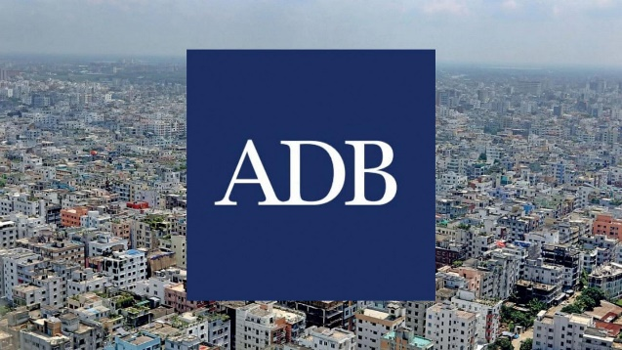

[**India players gain big in ICC Men's Test Rankings**](https://www.thedailystar.net/sports/cricket/news/india-players-gain-big-icc-mens-test-rankings-3711811)

India players Rishabh Pant, Shubman Gill and Ravichandran Ashwin have all prospered in the ICC Men’s Test Batting Rankings after compiling centuries in the first match of their ICC World Test Championship series against Bangladesh playe

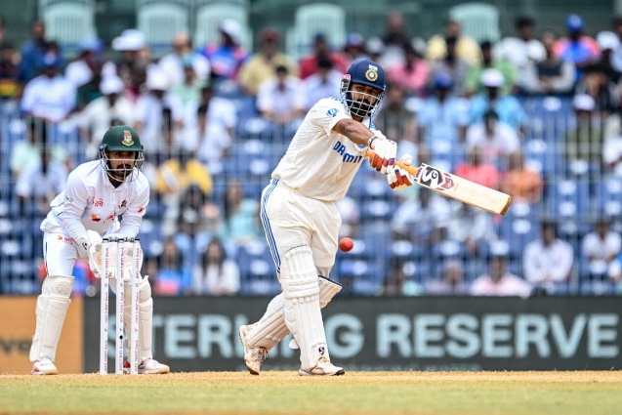

[**Shakib available for selection for Kanpur Test, says Hathurusingha**](https://www.thedailystar.net/sports/cricket/news/shakib-available-selection-kanpur-test-says-hathurusingha-3711766)

**It was an interesting setting for the first Bangladesh press conference at the Green Park Kanpur stadium press conference room today, which was attended by head coac**

#### https://tds-images.thedailystar.net/sites/default/files/styles/very_big_1/public/images/2024/09/25/azmin_3.jpg

#### [**UK MP Apsana Begum calls for investigation into ex-minister Saifuzzaman**](https://www.thedailystar.net/news/news/uk-mp-apsana-begum-calls-investigation-ex-minister-saifuzzaman-3711776)

She emphasised that corruption has severely impacted Bangladesh's living standards, workplace rights, and democrat

#### [**ADB cuts Bangladesh’s growth forecast due to political unrest**](https://www.thedailystar.net/business/news/adb-cuts-bangladeshs-growth-forecast-due-political-unrest-3711626)

The ADB has lowered its forecast for Bangladesh’s economic growth to 5.1 percent for the current fiscal

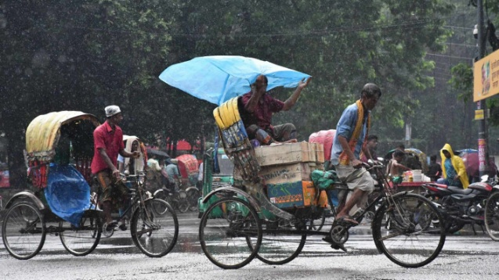

#### [Rain likely till September 12: BMD](https://www.thedailystar.net/news/bangladesh/news/rain-likely-till-october-12-bmd-3720116)

The temperature might start falling after mid-September

Roll:26_Office -16_Nabila Jahan



### [Education, identity and ideology: Bangladesh's struggle for unity](https://www.thedailystar.net/opinion/views/blowin-the-wind/news/education-identity-and-ideology-bangladeshs-struggle-unity-3719966)

"The 2024 uprising as an opportunity to return to the original desires of the deprived and persecuted masses of 1971.